**CONCEPTUAL EERD**

PROJECT TITLE:

FIND YOURSELF A MENTOR

Group Name:

INTELLECTUALS

MEMBERS:

1)Mahnoor Maleeka Shehzad (2020217).

2) Saad Khan(2020414).

ENTITIES:

1. University
2. Gikians
3. Other
4. Mentor
5. Mentees

RELATIONSHIP:

Gikians have Mentees and Mentors(M : N).

Mentees have a Mentor(N : 1).

Mentor have Mentees(1 : N).

Assumptions:

Other entity represents the other universities that might be added later on.

EERD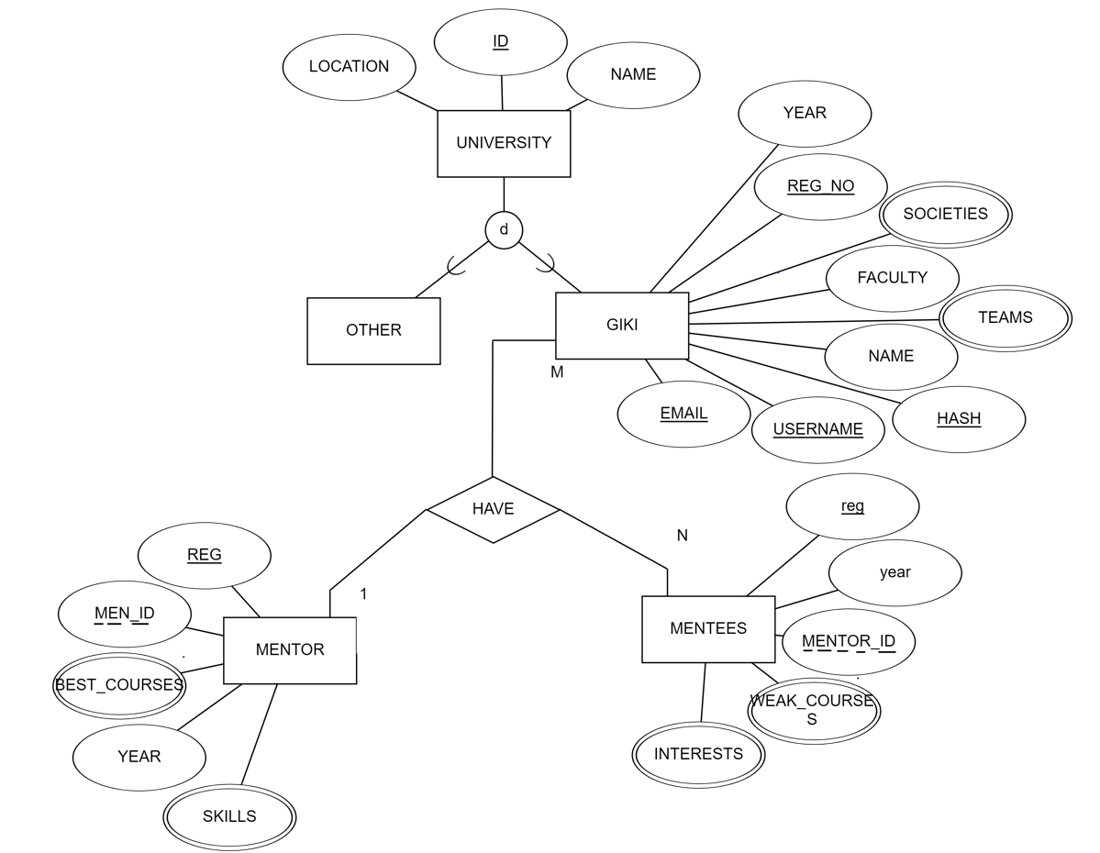:

GIKIANS

